12.3 Across the period
Name: ____________________ Class: ____________________ Due date: 3.18
1. Which statement about nitrogen and phosphorus is not correct? （ ）
A Both are in the same group of the Periodic Table.
B Both are in the same period of the Periodic Table.
C Both are non- metals.
D Both have the same number of electrons in their outer shell.

2. Which property of elements increases across a period of the Periodic Table?（ ）
A metallic character
B number of electron shells
C number of outer shell electrons
D tendency to form positive ions

3. Which statement about the Periodic Table is correct? （ ）
A Elements in the same group have the same number of electron shells.
B It contains elements arranged in order of increasing proton number.
C Metals are on the right and non- metals are on the left.
D The most reactive elements are at the bottom of every group.

4. Which row about elements in the Periodic Table is correct? （ ）
 | statement 1 | statement 2
A | two elements in the same group have similar chemical properties | metals are on the left of the table
B | two elements in the same group have similar chemical properties | metals are on the right of the table
C | two elements in the same period have similar chemical properties | metals are on the left of the table
D | two elements in the same period have similar chemical properties | metals are on the right of the table

5. W, X, Y and Z are elements in the same period in the Periodic Table.
W and Y are metals. X and Z are non- metals.
Which shows the correct order of these elements across the period? （ ）
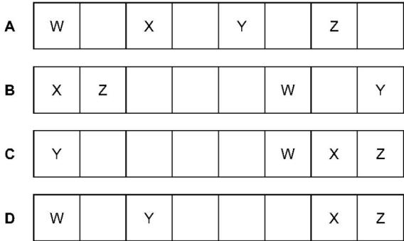

6. Five elements have proton numbers 10, 12, 14, 16 and 18.
What are the proton numbers of the three elements that form oxides? （ ）
A 10, 12 and 14
B 10, 14 and 18
C 12, 14 and 16
D 14, 16 and 18

7. The diagram shows an outline of the Periodic Table.
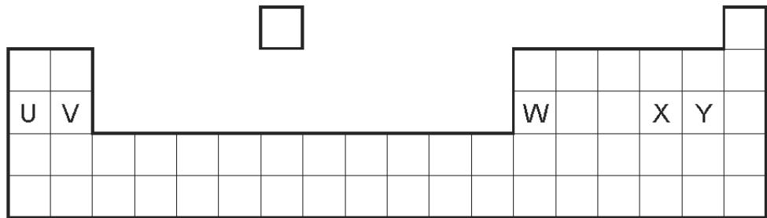
Which of the elements U, V, W, X and Y would react together in the ratio of 1:1?（ ）
A U and X B U and Y C V and Y D W and X

8.Calcium, on the left of Period 4 of the Periodic Table, is more metallic than bromine on the right of this period.
Why is this? Calcium has （ ）
A fewer electrons.
B fewer protons.
C fewer full shells of electrons.
D fewer outer shell electrons.

9. Where in the Periodic Table is the metallic character of the elements greatest? （ ）
 | left or right side of a period | at the top or bottom of a group
A | left | bottom
B | left | top
C | right | bottom
D | right | top

10. A period of the Periodic Table is shown.
group | I | II | III | IV | V | VI | VII | VIII
element | R | S | T | V | W | X | Y | Z
The letters are not their chemical symbols.
Which statement is correct? （ ）
A Element R does not conduct electricity.
B Elements R and Y react together to form an ionic compound.
C Element Z exists as a diatomic molecule.
D Element Z reacts with element T.
11 .Part of the Periodic Table is shown.
Which element forms an oxide that reacts with dilute acid to form a salt and water? （ ）
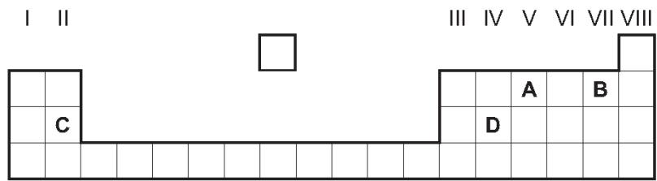
12. Elements P and Q have the same number of electron shells.
Q has more electrons in its outer shell than P.
Which statements are correct? （ ）
1 P and Q are in the same group of the Periodic Table.
2 P and Q are in the same period of the Periodic Table.
3 P has a greater tendency to form positive ions than Q.
4 The oxides of Q are more basic than those of P.
A 1 and 3 B 1 and 4 C 2 and 3 D 2 and 4

13. The table below includes information about some of the elements in Period 2.
element | carbon | nitrogen | fluorine | neon
symbol | C | N | F | Ne
structure | macromolecular | simple molecules N₂ | simple molecules F₂ | single atoms Ne
boiling point/℃ | 4200 | -196 | -188 | -246
Why does neon exist as single atoms but fluorine exists as molecules?
What determines the order of the elements in a period?
14. - (0620- S 2013- Paper 4 (Extended)/1- Q2) - ACIDS AND BASES, THE PERIODIC TABLE
$2+8+18+3$An element, M, has the electron distribution
Which group in the Periodic Table is element M likely to be in?
...................................................................................................................................[1]
Predict whether element M is a poor or a good conductor of electricity. Give a reason for your answer.
...................................................................................................................................[1]
Binary compounds contain two atoms per molecule, for example HCl.
Identify an element which could form a binary compound with element M.
..................................................................................................................................[1]
${SO}_{4}^{2−}$Predict the formula of the sulfate of M. The formula of the sulfate ion is
.................................................................................................................................[1]
15. The table below shows the elements in the third period of the Periodic Table, the number of electrons in their outer energy level, their oxidation state in their common compounds and their melting points.
element | Na | Mg | Al | Si | P | S | Cl | Ar
number of outer electrons | 1 | 2 | 3 | 4 | 5 | 6 | 7 | 8
oxidation state | +1 | +2 | +3 | +4/-4 | -3 | -2 | -1 | 0
melting point/℃ | 98 | 650 | 660 | 1414 | 317 | 115 | -101 | -189
Describe and explain the variation in oxidation state across the period.
.......................................................................................................................................
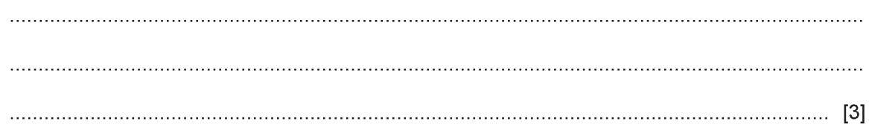
Explain why Na, Mg and Al are good conductors of electricity.
...........................................................................................................................................................................................................................................................................[1]
$X_{2}$Which element exists as diatomic molecules of the type ?
...................................................................................................................................[1]

